# [**Sorry, SVU Writers, Fans Don't Like the Idea of Olivia and Stabler Together**](https://startefacts.com/news/sorry-svu-writers-fans-don-t-like-the-idea-of-olivia-and-stabler-together_a115)

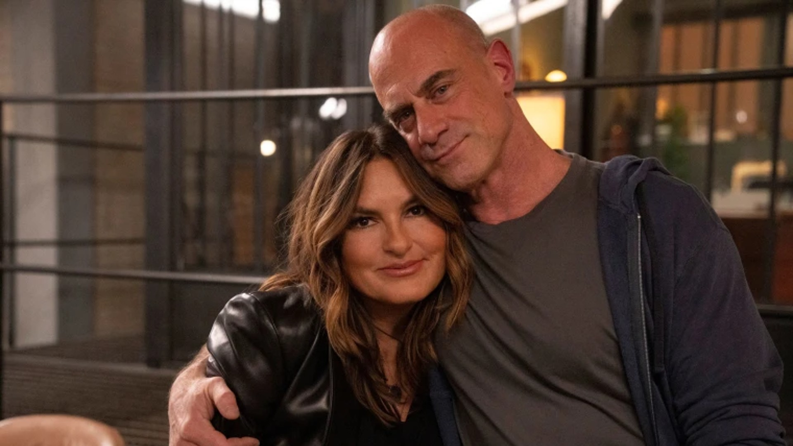Image credit: NBC

Now that the romance between Benson and Stabler has become a definite possibility, fans are not sure the SVU creators should go that route.

Besides being TV's longest-running primetime U.S. live-action series in the history of television, Law & Order: Special Victims Unit probably broke another record, the longest slow burn ever featured in a show.

Since 1999, for 12 years, SVU fans watched partners Olivia Benson and Elliot Stabler become closer while solving crimes together. Many fans, at one point or another, wished the characters get out of their mutual friend zone and enter a passionate relationship. But it never happened.

Between Seasons 12 and 13, Christopher Meloni, the actor playing Stabler, and the studio had a disagreement about the star's salary and he left the show.

[SVU's Benson Under Fire for Her Parenting Choices in Season 24](https://startefacts.com/news/svu-s-benson-under-fire-for-her-parenting-choices-in-season-24_a121)

Because he left in-between seasons, the character got no proper farewell scene which disappointed many fans. However, Meloni returned to his role in 2021 when an SVU spinoff titled Organized Crime hit the screens. More than that, Stabler returned with some tragic news. His wife Kathy had died which, while being devastating for the character, opened the way for the Benson-Stabler romance. Both characters already admitted in their respective spinoffs that the chance of a romantic relationship was very real and that made fans take to social media to discuss whether they were excited about the possibility.

*"I love Benson and Stabler both and their friendship. But their love story? I don't like it. It seems tacky and even if it wasn't I feel like Benson and Stabler are like brother and sister," Redditor u/*[*ke-aviles*](https://www.reddit.com/r/SVU/comments/tkkxy7/benson_and_stabler_not_loving_it/) *wrote on r/SVU Subreddit.*

This message started a long discussion that gathered many fans who agreed that the romantic relationship between the two characters was totally unnecessary and felt weird. The most popular comment [stressed](https://www.reddit.com/r/SVU/comments/tkkxy7/comment/i1ratxh/?utm_source=share&utm_medium=web2x&context=3) that Benson had outgrown Stabler for romance to really be an option. Besides, there is an issue of intersexual friendship in long-running shows.

*"I've always felt that a man and woman can be friends without a romantic/sexual relationship being a part of it," the author of the comment wrote.*

Other fans agreed that a love storyline would ruin one of the few fictional cross-sex relationships that didn't go the romantic route. Time will tell if the creators listen to dedicated fans or decide to finally let two ex-partners be together.